CHAPTER 3
MOTION IN TWO OR THREE DIMENSIONS
Discussion Questions
Q3.1 The mass travels in an arc of a circle, so its radial acceleration is 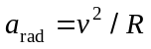. At the end point its speed is zero so 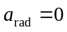. The tangential component of acceleration causes the speed to change from zero. Therefore, at the ends of the swing the acceleration is tangent to the arc of swing and directed toward the midpoint. At the midpoint the speed of the mass is a maximum. There is a radial acceleration , directed upward. Since the speed is a maximum, 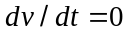 and 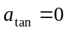. At the midpoint the acceleration is radially upward. At the end points the acceleration is tangential and at the midpoint it is radial. At points in between both radial and tangential components of the acceleration are nonzero.

Q3.2 See Fig. DQ3.2. There is no component of perpendicular to , so the direction of doesn’t change and the particle moves in a straight line. Since and are in opposite directions, the speed is decreasing (the particle is slowing down).

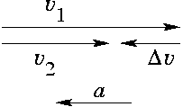

Figure DQ3.2
Q3.3 is always vertically downward and is always tangent to the path. There is no point where and are parallel. At the maximum height is horizontal so that at that point and are perpendicular.
Q3.4 (a) The vertical component of the initial velocity remains zero and the time the book remains in the air is unchanged. The vertical motion is unaffected by the horizontal component of the initial velocity. (b) The horizontal distance the book travels while in the air doubles. The horizontal displacement is 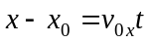. 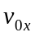doubles while stays the same so 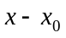 doubles. (c) The seed of the book just before it reaches the floor is 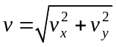. 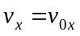 since 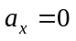 so 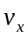 doubles. 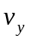 is unchanged. increases, but by less than a factor of two.
Q3.5 The downward acceleration due to gravity doesn’t depend on the horizontal velocity. Both bullets travel downward the same distance to reach the ground and both initially have zero vertical component of velocity, so both strike the ground at the same time.

Q3.6 After it falls out, the package maintains the horizontal component of velocity that it had while in the plane since it has no horizontal acceleration after it falls out. It accelerates downward due to gravity. Relative to the pilot the package travels straight down. Relative to a person on the ground the package travels both horizontally and vertically; the path relative to this person is a parabola.

Q3.7 The graphs are sketched in Fig. DQ3.7. 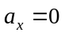, 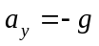. 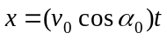, 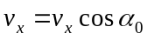. 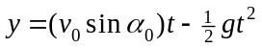, 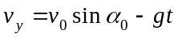. 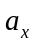 and 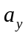 are constant. 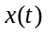 is a straight line and 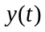 is a parabola. 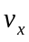 is constant and 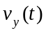 is a straight line.

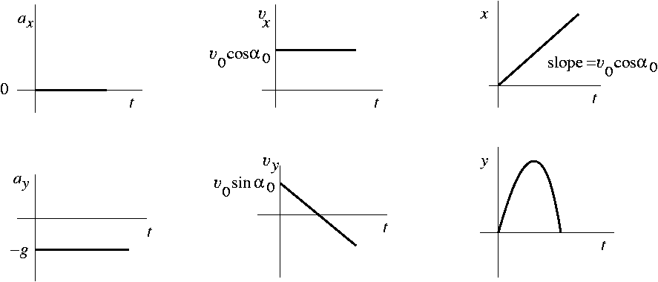

Figure DQ3.7
Q3.8 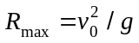. If the frog jumps straight up 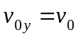 and 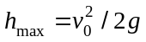 is the maximum height. Therefore 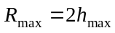.

Q3.9 With 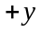upward the initial velocity has components 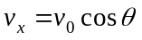 and 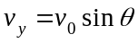. At the maximum height, 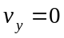. Since , is constant and at the maximum height . Therefore, at the maximum height the velocity vector is 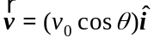 and the speed is 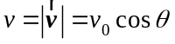. Throughout the motion the acceleration is g, downward, so at the maximum height the acceleration vector is 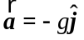.
Q3.10 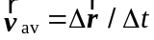. For one revolution the object returns to its starting point, so 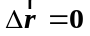 and 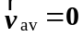. 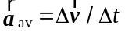. After one revolution the velocity vector returns to its initial value so 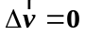 and 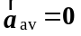. In circular motion the directions of the velocity and acceleration are continually changing and average to zero over one complete revolution.
Q3.11 . If the speed is increased by a factor of 3, the acceleration increases by a factor of 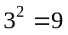. When the radius is decreased by a factor of 2 the acceleration increases by a factor of 2.

Q3.12 In circular motion, uniform or not, the velocity vector is tangent to the circular path. If the speed is not constant the acceleration has a tangential component and the acceleration is not perpendicular to the velocity.

Q3.13 The raindrops fall in the vertical direction relative to the ground. Their velocity relative to the moving car has both vertical and horizontal components and this is the reason for the diagonal streaks on the side window. The diagonal streaks on the windshield arise from a different reason. Air resistance pushes the drops off to one side of the windshield.

Q3.14 Hold the umbrella at an angle, so that the handle is parallel to the motion of the raindrops. This presents the greatest umbrella cross section to the rain.

Q3.15 To cross the river in the shortest time your velocity relative to the earth has the largest possible component perpendicular to the bank. Let S be the swimmer, E be the earth and W be the water. 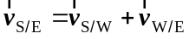 . 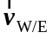 is parallel to the bank, so 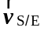 has its largest component perpendicular to the bank when 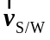 is in that direction. To cross the river in the shortest time you should head straight across. The current will then carry you downstream, so your path relative to the earth is directed at an angle downstream.
Q3.16 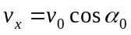, where 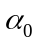 is the launch angle, is constant throughout the motion, since . 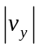 decreases to zero and then starts to increase. The speed is 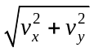. At 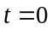, 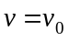. At the maximum height the speed has decreased to 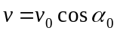, and then it increases. So, during the motion the speed reaches a minimum at the maximum height, but this minimum speed is not zero. Only graph (d) shows this behavior.

